Hors D’ Oeuvres

Hot Cold
Cheese Arancini with Tomato and Basil Confit Beet with Whipped Goat Cheese
Truffle Mushroom Soup Shooter Smoked Salmon with Cucumber and Dill Yogurt
Cumbrae Beef Sliders with Cheddar Cheese Fresh Spring Rolls with Tamari Dip
Popcorn Perch with Lemon Aioli Heirloom Carrots with Roasted Garlic Hummus
Crispy Sweet and Sour Cauliflower Mushroom Flatbread with Arugula and Grana Padano
Chickpea Fritters with Cucumber and Dill Yogurt Roasted Red Pepper with Rosemary Goat Cheese
Mac and Cheese Croquettes Elk Summer Sausage on Crostini with Merlot
Bellavitano
This is a sample list and subject to availability

Pre-Dinner Cocktail Service
Recommended time is around 1 – 1.5 hrs before seated dinner/lunch service
Service includes approximatel
y 6-8 bite size pieces per person
Choose 6 hors d’ oeuvres from the list above.
$15 per person
Cocktail Party Service
Recommended time is around 1.5 - 3 hrs
Service includes approximately 12-14 bite size pieces per person
Choose 8 hors d’ oeuvres from the list above.
$27 per person

Stationary Platters
Small Platters 12-18 people, Medium 18-22 people, Large Platter 22-30 people

Assorted veggies with Roasted Red Pepper Goat Cheese Dip and Hummus
Small $35
Medium $50
Large $75

Artisanal Cheese Platter served with Local Honey, Crackers and Dried Fruits
Small $95
Medium $125
Large $180

Assorted Charcuterie Served with Grainy Mustard, Pickles, Mixed Olives, House Made Pan Bread
Small $80
Medium $110
Large $145

Assortment of Melons, Berries and Seasonal Fruit
Small $55
Medium $85
Large $100

Hot Appetizer Platter
Small $80
Medium $120
Large $160
**Ingredients based on seasonality and can change slightly without notice
Event Menus

Lunch #1

First Course
Leek and Potato soup with house smoked bacon and parsley gremolata
Or
Arugula Salad with Julienne Vegetables, Cider Maple Vinaigrette and Grana Padano

Second Course
(Served with French Fries)

8 oz Cumbrae Farms Burger on Soft bun with Caramelized Onions, Ketchup, Lettuce, Mayo, Cheddar Cheese and a Dill Pickle
Or
Chicken Bacon Avocado – Herb Roasted Chicken, Avocado, Lemon Aioli, Arugula and Grana Padano on Multi Grain Bread
Or
Roasted Sesame Crusted Rainbow Trout with Fresh Julienne Vegetables, Tamari Vinaigrette, Cashews and Crispy Rice Noodles

$22 per person

Lunch #2

First Course
Leek and Potato Soup with Smokey Bacon and Parsley Gremolata
Or
Arugula Salad with Julienne Vegetables, Cider Maple Vinaigrette and Grana Padano

Second Course
Fusilli with Roasted Vegetable Ragu, Fresh Mozzarella, Basil and Grana Padano
Or
Seared Rainbow Trout Almandine, Green Beans, Brown Butter, Capers, Lemon, Maple Roasted Squash
Or
Roasted Chicken Supreme in a Porcini Cream Sauce with Herb Roasted Potatoes, and Parm-Baked Broccoli

$28 per person

Additional
Dessert
Host Chooses from either:
Dark Chocolate Terrine with white chocolate crumble and vanilla whip cream
or
Vanilla Bean Panna Cotta with Seasonal Berries

$5/Person

Coffee and Tea Service
$2.50 Per Person

Appetizer Platter (serves 4-6)
Crispy Green Beans, Buttermilk Fried Cauliflower, Popcorn Perch with Lemon Aioli and Brussel Sprouts with Aged Balsamic

$37.50 Per Platter

Dinner

Dinner #1
First Course
Leek and Potato Soup with Smoky Bacon and Parsley Gremolata
Or
Arugula Salad with Julienne Vegetables, Cider Maple Vinaigrette and Grana Padano

Second Course
Fusilli with Roasted Vegetable Ragu, Fresh Mozzarella, Basil and Grana Padano
Or
Seared Rainbow Trout Almandine, Green Beans, Brown Butter, Capers, Lemon, Maple Roasted Squash
Or
Roasted Chicken Supreme in a Porcini Cream Sauce with Herb Roasted Potatoes, and Parm-Baked Broccoli
Or
8 oz Cumbrae Farms Burger on Soft bun with Caramelized Onions, Ketchup, Lettuce, Mayo, Cheddar Cheese, a Dill Pickle and French Fries

Dessert
Chocolate Terrine – with white chocolate crumble and whip cream

Coffee and Tea Service

$35 per person

Dinner #2
First Course
Leek and Potato Soup with Smoky Bacon and Parsley Gremolata
Or
Arugula Salad with Julienne Vegetables, Cider Maple Vinaigrette and Grana Padano
Second Course
All mains served with Smashed Fingerling Potatoes and Garlic Roasted Brocolini
Slow Roasted Organic Salmon with Confit Tomato Salsa
Or
Roasted Beef Striploin with Bearnaise and Roasted Mushrooms
Or
Herbed Goat Cheese Stuffed Chicken Supreme with Roasted Red Pepper Emulsion
Dessert
Dark Chocolate Terrine with White Chocolate Crumble and Vanilla Whip Cream
or
Vanilla Panna Cotta with Mixed Berries and Mint

Coffee and Tea Service

$45 per person

Dinner #3

First Course
Cream of Cauliflower with Truffle Emulsion and Crispy Parsnips
Or
Shaved Fennel, Frisee and Citrus Salad with Tamari Vinaigrette and Seedlings
Second Course
Roasted Pacific Halibut with Potato and Porcini Pave, Seedling and Fine Herb Salad with Apple Cider Vinaigrette
Or
Roasted Beef Tenderloin with Roasted Mushroom and Peppercorn Sauce, Garlic Rapini and Potato and Porcini Pave
Or
Roasted Wellington County Game Hen with Slow Roasted Baby Carrots, Potato and Porcini Pave and Coriander-Honey Glaze
Dessert
Dark Chocolate Terrine with White Chocolate Crumble and Vanilla Whip Cream
or
Vanilla Panna Cotta with Mixed Berries and Mint
and
Coffee and Tea Service

$58 Per Person

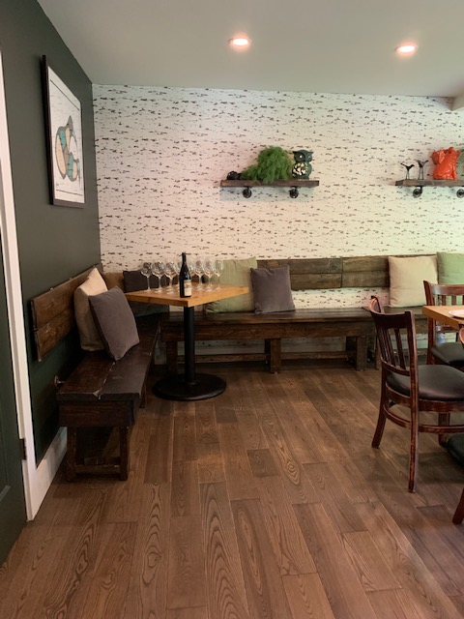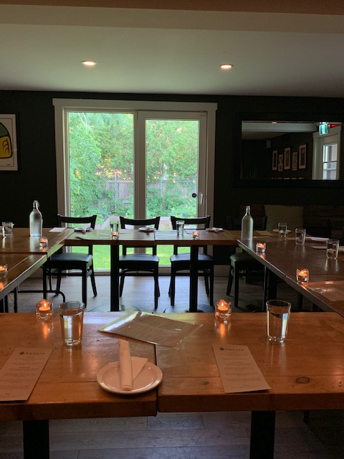
Photos of party set up in square for a group of 16 or less

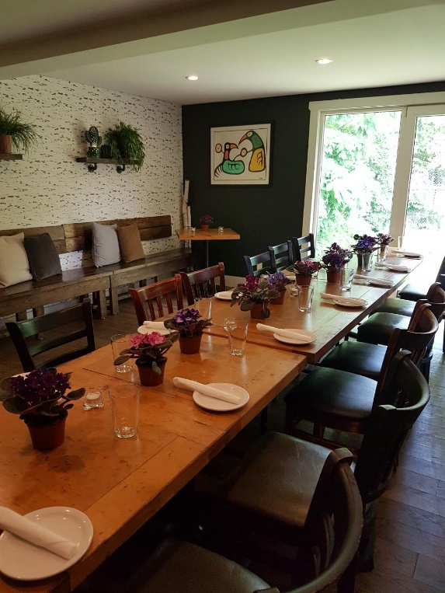Table set up for 12-15 people
If you would like to bring in decorations for your event, please let us know so we can accommodate you.

